

**CAR CARE**

Written to fulfill the 4th Project

**WAP**

Written by :

Linggar Jati Kusuma Wardhani ( 2120010342 )

Akhdan Khairu Nabiha ( 2120010014 )

Faculty :

Bagus Bayu Kencana, S. Kom.

Class :

2 SE 3

**CEP CCIT - Fakultas Teknik Universitas Indonesia Gedung Engineering Center Lt. 1, Kampus Baru UI Depok 16424**

**Developed by :**

1. Linggar Jati Kusuma Wardhani
2. Akhdan Khairu Nabiha



**PROJECT ON**

**CAR CARE**

**CAR CARE**

Batch Code : 2SE3

Start Date : 02 July 2022

End Date : 13 July 2022

Name of Faculty : Bagus Bayu Kencana, S. Kom.

Names of Developer :

1. Linggar Jati Kusuma Wardhani

2. Akhdan Khairu Nabiha

Date of submission : 14 July 2022

**CERTIFICATE**

This is to certify that this report titled **“CAR CARE”** embodies the original work done by **Linggar Jati Kusuma Wardhani** and **Akhdan Khairu Nabiha**. Project in partial fulfillment of their course requirement at NIIT.

Coordinator :

Bagus Bayu Kencana, S. Kom.

**ACKNOWLEDGEMENT**

Thank you, the writer wishes to God the Almighty for His blessings, we can complete this Project about Object Oriented Programming entitled “CAR CARE” for Friendly task both in the form of presentation and paper in a timely manner. Thank you especially to our faculty, Bagus Bayu Kencana, S. Kom. who had helped us. Thank you also to fellow students who have supported, and also thankyou for being fellow workers in the education at CCIT-FTUI.

The author realizes that in the preparation of this project there are still many shortcomings and is still far from perfection. Therefore, the authors expect constructive criticism and suggestion to improve this paper and can be a reference in preparing the papers or subsequent tasks.

Depok, 10 July 2022

Author

**SYSTEM ANALYSIS**

**System Summary :**

this website is a web to record vehicles that want to taken care, in this application there is input data, read data, update data and delete data. This program was developed using PHP and MySQL databases, using the XAMPP package. In making the program, using Netbeans, starting from the Home design, form design, to the design of the data display are all designed from Netbeans.

Activities list :

1. Home Page
2. Login Page
3. Daftar Mobil
4. Tambah Mobil
5. Edit Data
6. Invoice
7. Contact

**USER INTERFACE**

**Home View**

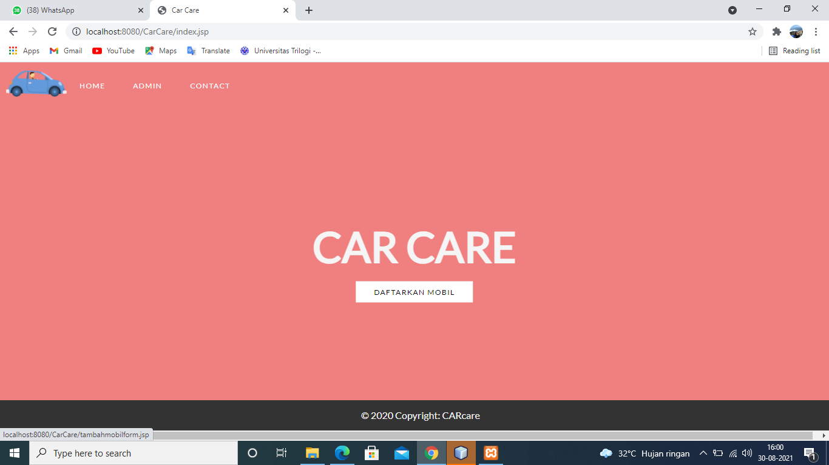

**Log in Admin View**

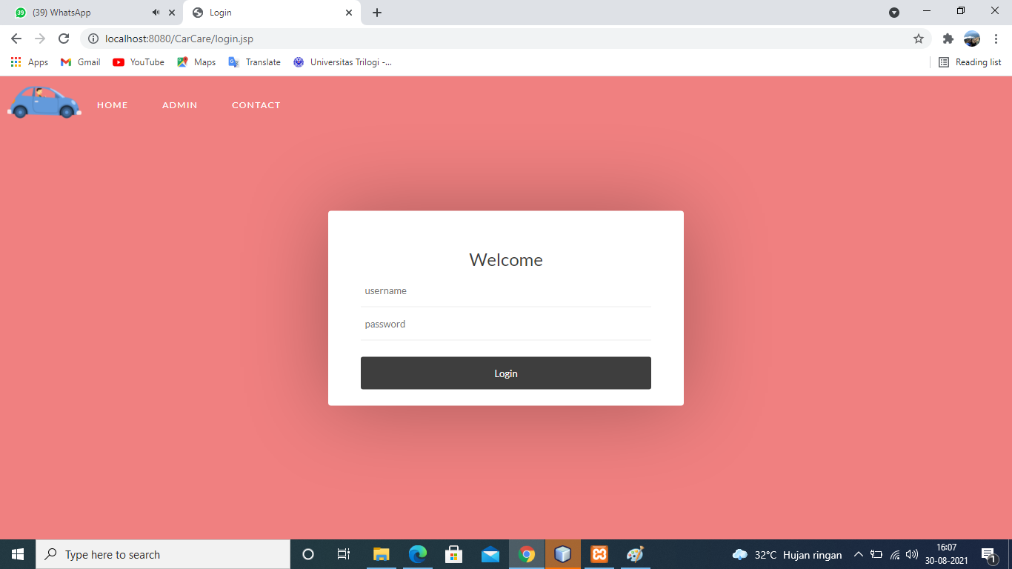

**DESIGN INTERFACE**

**Customer Data**

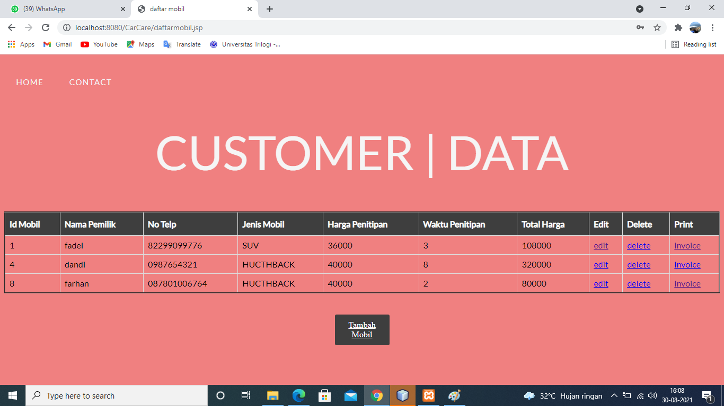

**Form Data**

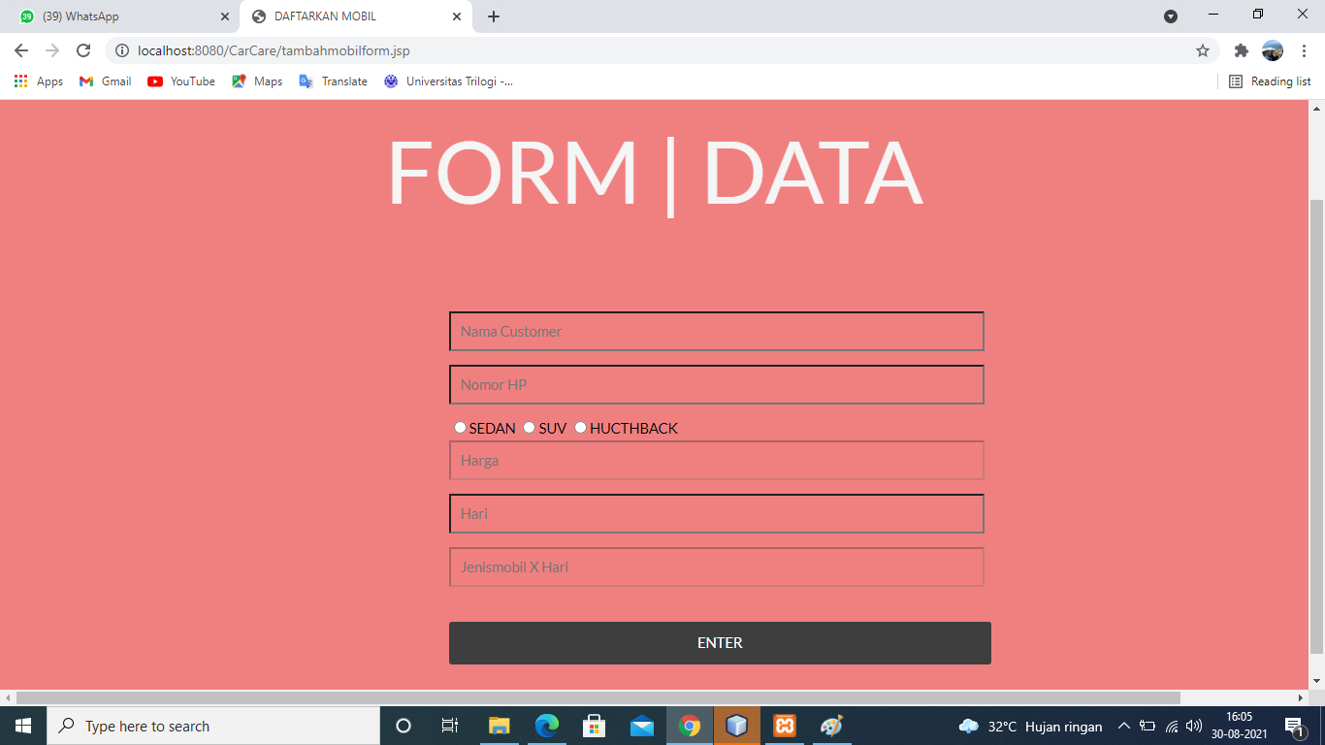

**USER INTERFACE**

**Edit View**

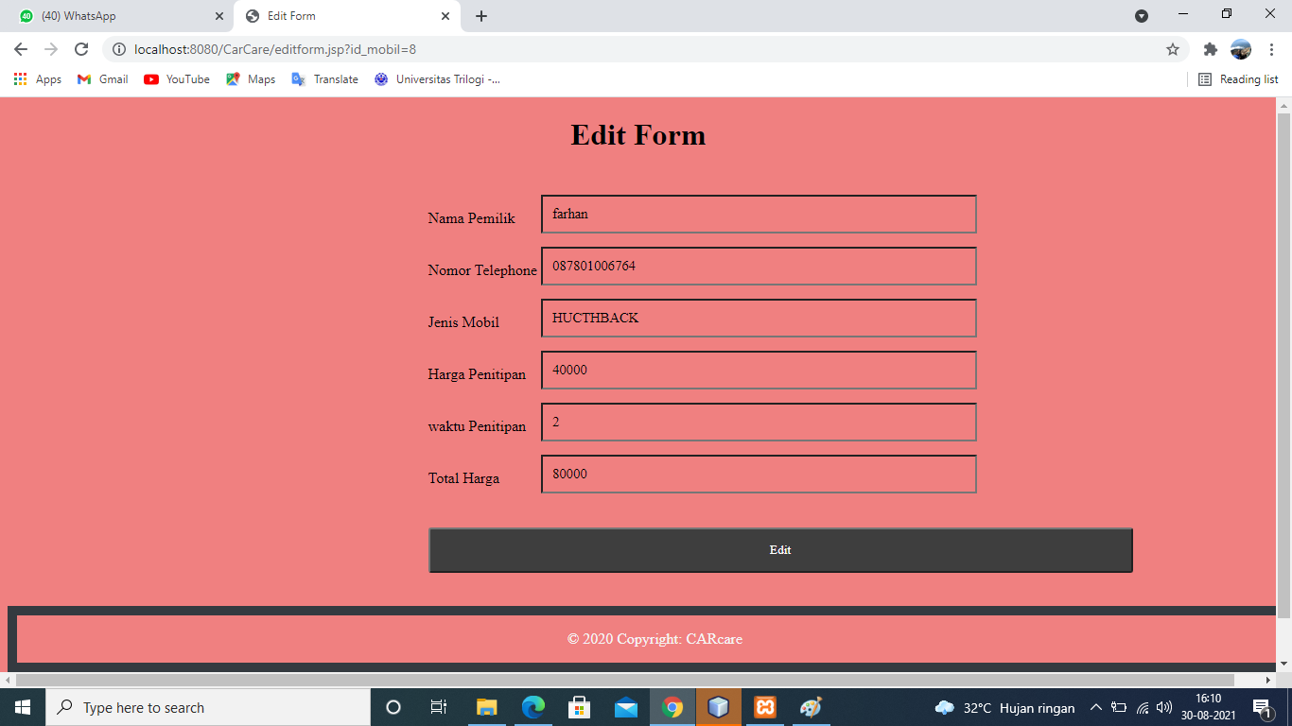

**ADMIN TABLE MENU**

**Invoice**

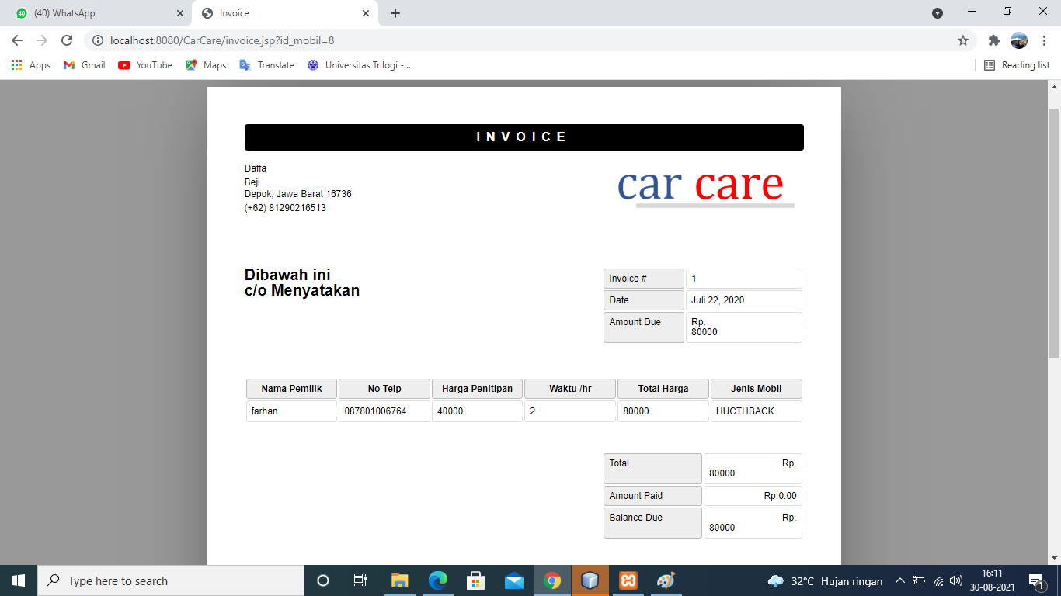

**ADMIN TABLE TRANSACTION**

**Contact**

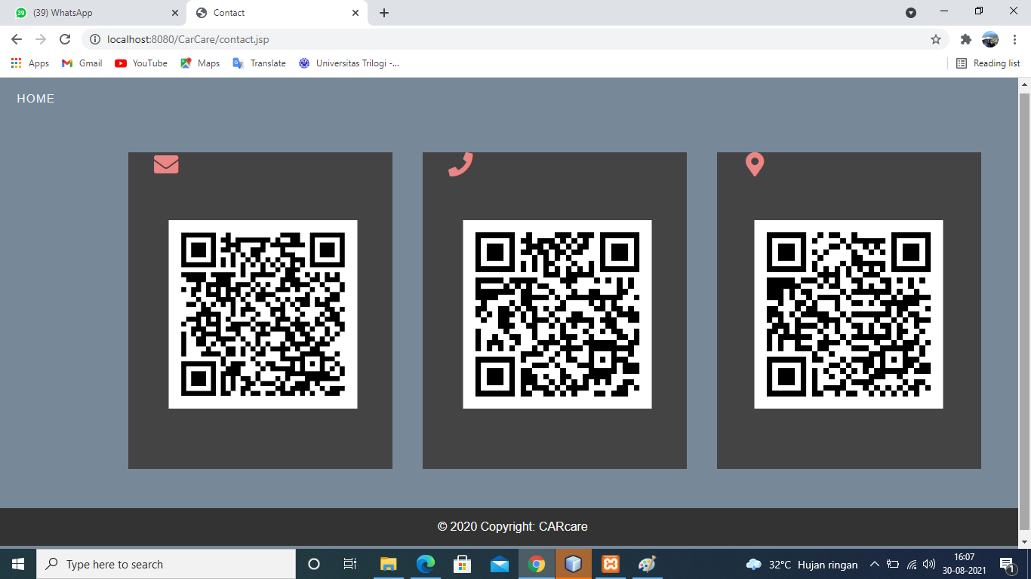

**CONFIGURATION**

Hardware : PC, Intel ® Core™ i3-3240 CPU @ 3.40GHz ( 4CPUs )

Operating System : Microsoft Windows 10

Software : Netbeans, Xampp

|  |  |  |
| --- | --- | --- |
| **PROJECT FILE DETAILS** | | |
| **No.** | **File Name** | **Remarks** |
| 1. | Car Care.docx | File from Microsoft Word that contains Report |
| 2. | Car Care.pptx | File from Microsoft Power Point that contains Presentation |
| 3. | Car Care | Netbeans Project that contains code |